

**THISTLE RESOURCES CORP. ANNOUNCES**

**Significant Gold Assay Results   
and Program Update @ Middle River Gold Project, NB**

**\*\*\*\*\* FOR IMMEDIATE RELEASE \*\*\*\*\***

**TORONTO, Ontario – (Sept 17th , 2019)**

Thistle Resources Corp. ("TRC" or the "Company") is pleased to provide an update on the current exploration program underway on its Middle River Gold Project, Bathurst, New Brunswick. The project is located 8 km north of the world class Brunswick 12 Volcanogenic Massive Sulphide (VMS) deposit and south of the VMS-SEDEX “Millstream Project” presently being explored by Royal Stewart Resources Corp.

In early July, 18 samples were collected from Trench #2 and submitted to Bureau Veritas Mineral Laboratories Canada for industry standard fire assay gold and multi-element ICP analysis. The results have been received and the gold and arsenic results are summarized below. We are very excited to report Gold results up to 3 grams per Ton

***Table 1: Assay Results, Trench #2, MRG Gold Deposit***

|  |  |  |
| --- | --- | --- |
| **Sample #** | **Au (g/t)** | **As (ppm)** |
|  |  |  |
| MRGTR2-013 | 1.3 | >10,000 |
| MRGTR2-014 | 0.9 | >10,000 |
| MRGTR2-015 | 0.16 | 9556 |
| MRGTR2-016 | 0.19 | >10,000 |
| MRGTR2-017 | 0.33 | >10,000 |
| MRGTR2-018 | 1.9 | >10,000 |
| MRGTR2-019 | 0.08 | 722 |
| MRGTR2-020 | 2.5 | >10,000 |
| MRGTR2-021 | 0.70 | >10,000 |
| MRGTR2-022 | 2.5 | >10,000 |
| MRGTR2-023 | 0.02 | 240 |
| MRGTR2-024 | 1.23 | >10,000 |
| MRGTR2-025 | 0.30 | 365 |
| MRGTR2-026 | 0.16 | >10,000 |
| MRGTR2-027 | 0.12 | 7060 |
| MRGTR2-028 | 2.0 | >10,000 |
| MRGTR2-029 | 3.0 | >10,000 |
| MRETR2-030 | 0.09 | 62 |

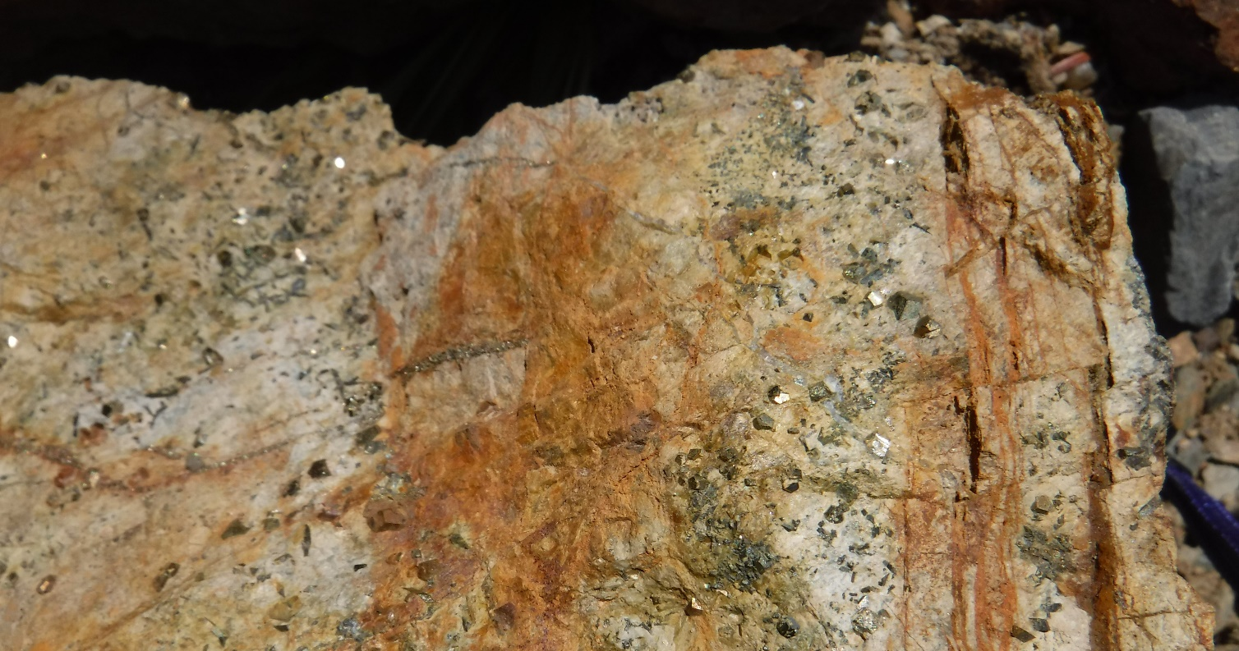

***Figure 1: Coarse grained Pyrite and Arsenopyrite crystals, (Gold is associated with Arsenopyrite) MRG Deposit***

***Figure 2: Field Technician KP sampling host rock, Trench 2, Middle River Gold Deposit***

The Project consists of 2 historic Gold Zones and a VMS target in the eastern portion of the claims area. 2019 Q1 work program focused on data compilation, a key piece being the 1994 Granges Exploration Ltd. soil program over northern and western portions of the present licence. Approximately 3,500 + samples were collected, the focus being the gold and associated arsenic values, the latter a pathfinder, used to trace out the gold mineralization at Middle River. After grid reconstruction, the results identified multiple base metal anomalies to the west of the MRG Gold Deposit in addition to an arsenic target south of Middle River.



***Figure 3: Middle River Project, Granges Soil Anomalies***

To assist in base metal target definition in the west, V.ickers Geophysics Inc, Bathurst, New Brunswick has been engaged to complete approximately 90 kilometers of Ground Magnetics and VLF-EM. To date, approximately 1/3 of the program is complete, the balance expected within the next few weeks (Figure 2).

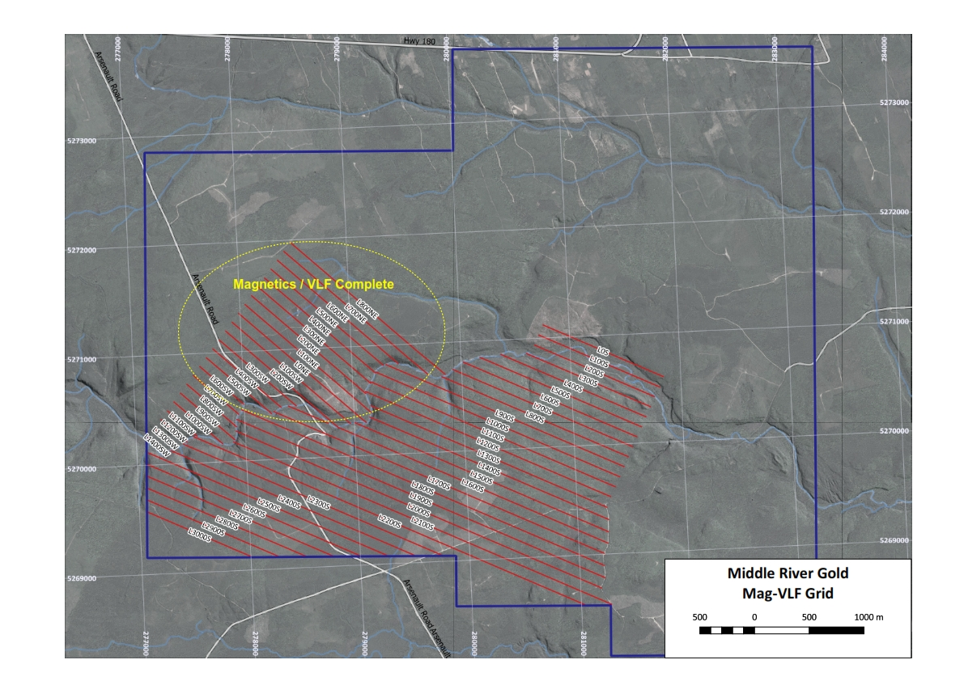

***Figure 4: Ground Magnetics / VLF Grid***

In addition, in an area South of Middle River, the team has been investigating an isolated arsenic anomaly, the location coincident with the geological horizon that hosts the MRG deposit. In order to validate the Granges results, soil sampling is being conducted over the target. The Team is currently prospecting the area. We believe the MRG Deposit extends south and is possibly a much larger Gold Deposit System.

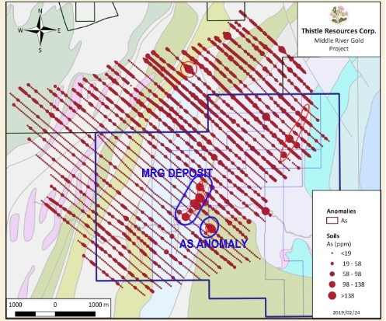

***Figure 5: MRG Deposit and Southern As Soil Anomaly***

Thistle Resources has received its permit Permit from the Department of Mines in Bathurst that would allow the Company to re-open 2 historical trenches at Middle River. The trenches define the deposit and the work program will allow geologists the opportunity to examine the host rocks and collect larger samples for assay and metallurgical testing.

Approval for all the permits are anticipated in the next 3 -4 weeks. Thistle Resources Corp. looks forward to our next update shortly on our Cape Breton Gold Project.

*“We are very excited to share these significant Gold Results in this update, and we are highly motivated to discovery the size and depth of the current Middle River Gold Deposit, which is all open @ depth. We also are excited to test the formation to the south to explore the potential increase to the size of this system. When we receive the soil results over the southern Arsenic Anomaly, we look forward to presenting those in the coming weeks. This confirmation that the existing deposit has surpassed the grade expectations and confirming a deeper source will be tested with our upcoming drill program, once our Trenching & Soils grid is completed, stated Patrick J Cruickshank, MBA , President & CEO.”*

Thistle Resources Corp.(TRC) is a private Canadian Junior Exploration Company focused on Gold-VMS exploration opportunities in the famous Bathurst Mining Camp (BMC) in Bathurst, New Brunswick & Cape Breton, Nova Scotia.

Mr. Gary Lohman, B.Sc., P. Geo. Thistle Resources Corp., COO and a qualified person under NI 43-101 has reviewed and approved the technical portion of this news release.

*The opinions, estimates, and/or projections contained herein are those of Thistle Resources Corp. (TRC) as of the date thereof and are subject to change without notice. TRC makes every effort to ensure the contents contained herein have been compiled or derived from sources believed reliable and contain information and opinions, which are accurate and complete. However, TRC makes no representations or warranty, express or implied, in respect thereof, takes no responsibility for errors or emissions which may be contained herein and accepts no liability whatsoever for information and its contents. The information contained herein is not to be construed as an offer to sell or solicitation for an offer to buy any securities. The officers, directors or employees may from time to time acquire, hold or sell securities mentioned herein.*

